Name:Jeevan S U

**Name: Jeevan S U**

**Roll No: 241059038**

**Subject: Linux OS and Scripting**

**Program: M.E in Cyber Security, MSIS, MAHE**

1. write a shell script to get value the pattern and file name from the user and check the pattern exists or not. If the pattern exists print the relevant message , if pattern not found print relevant message.

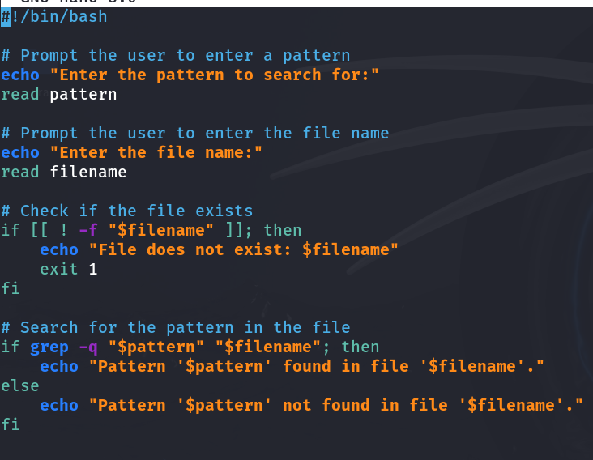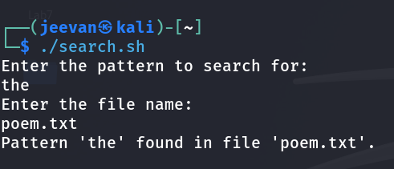

1. Modify the above script to pass the arguments from command line arguments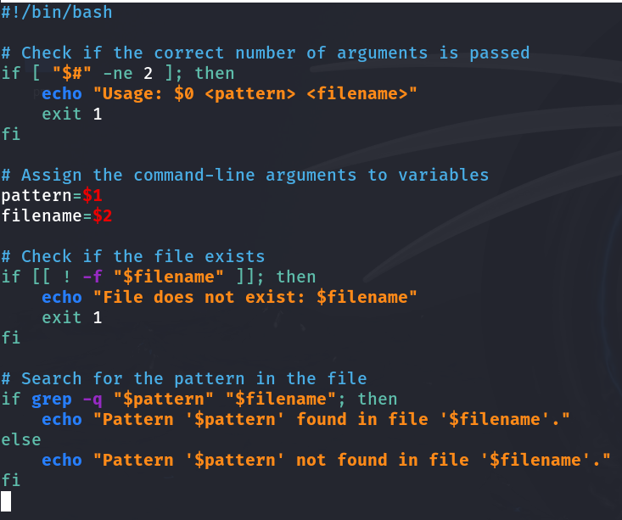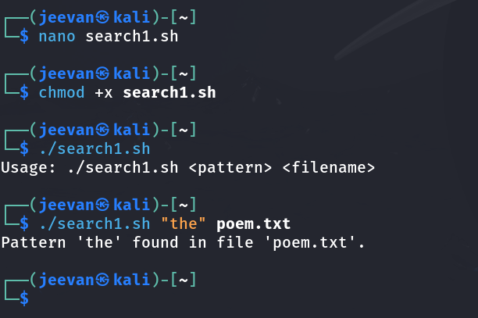
2. Modify the above script to pass the values inside the script.

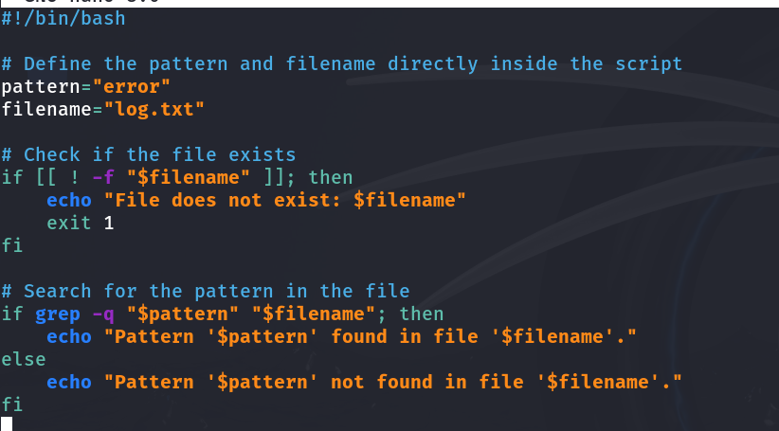

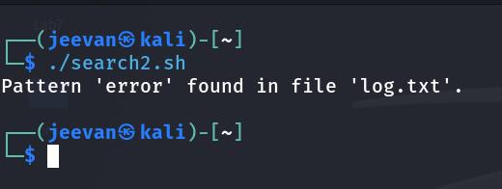

4. validate the script (script 1, script 2)

- the file exists or not

- arguments passed or not

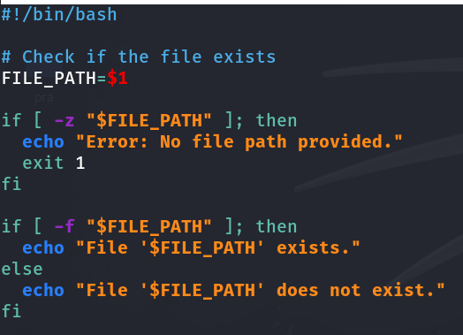

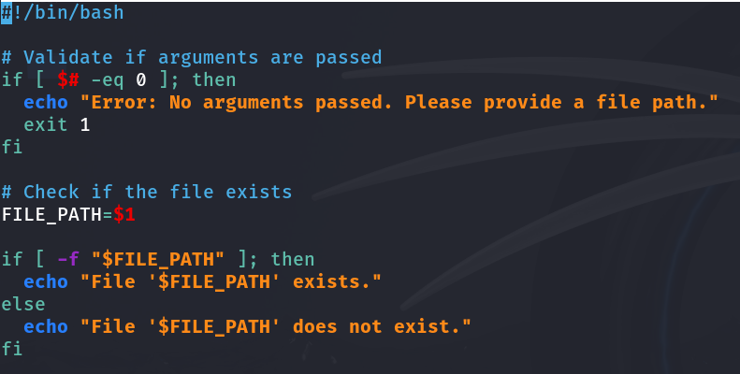

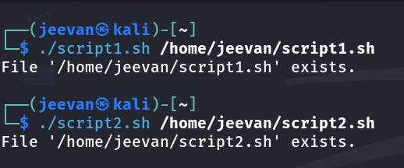

5. Apply grep commands

Note: Make sure to use the options -e -c -n -q -s -f -A -B -C -i -h, -l -o -w

Frame the questions (as per your choice)

to extract user information

to extract network information

to extract login details

Random systemlog file: 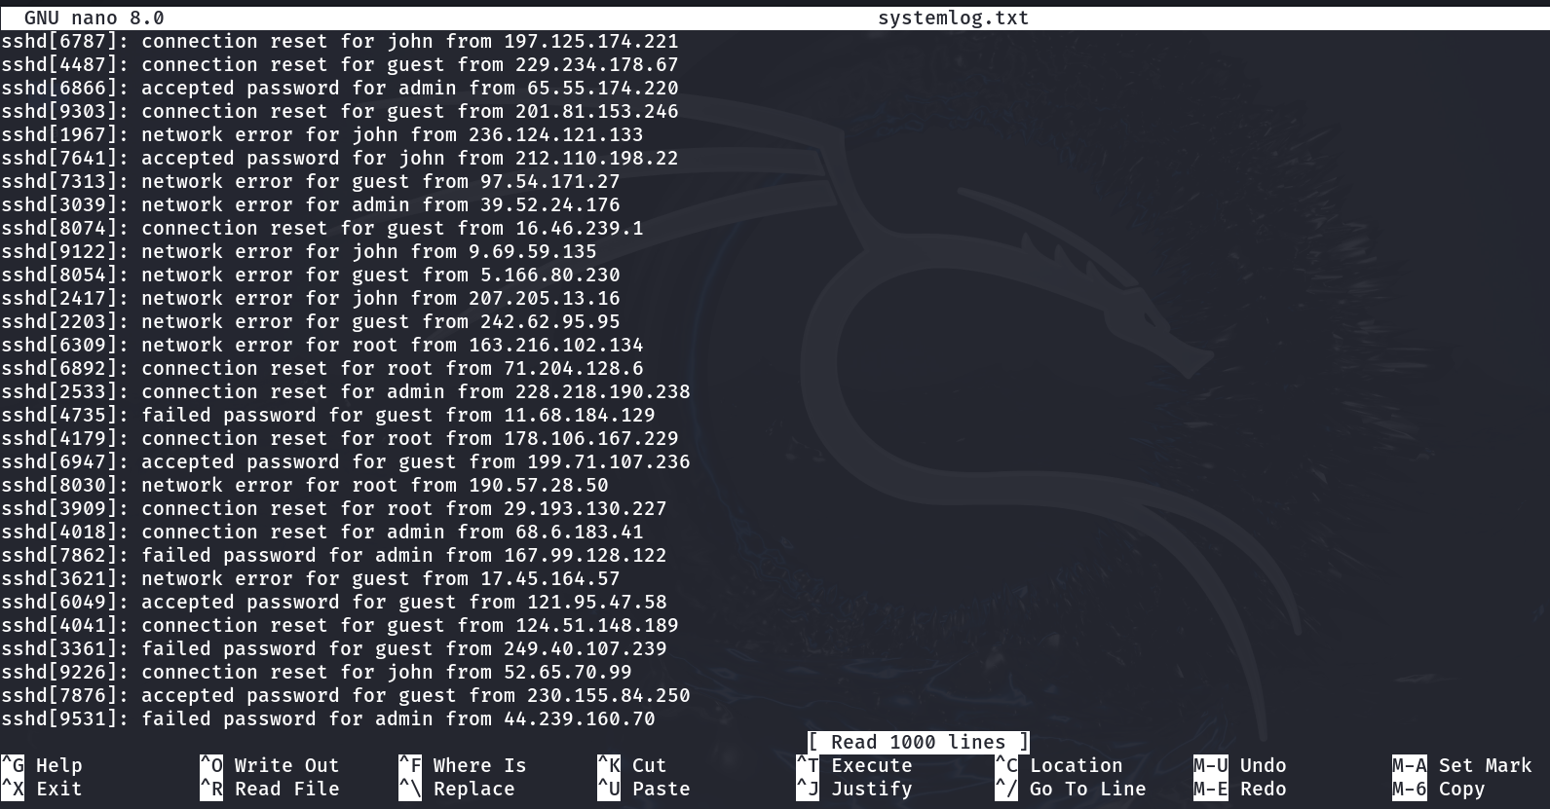

**List all users (usernames)** in the system:

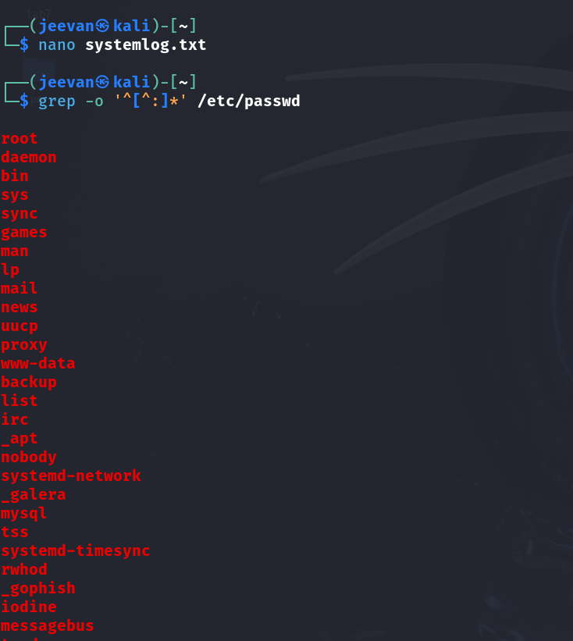

**Count the number of users** in the system:

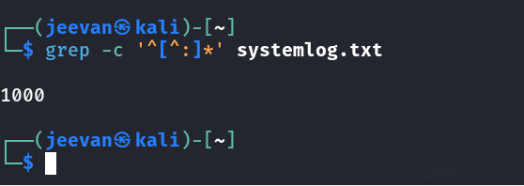

**Display line numbers** where usernames appear in the systemlog.txt file:

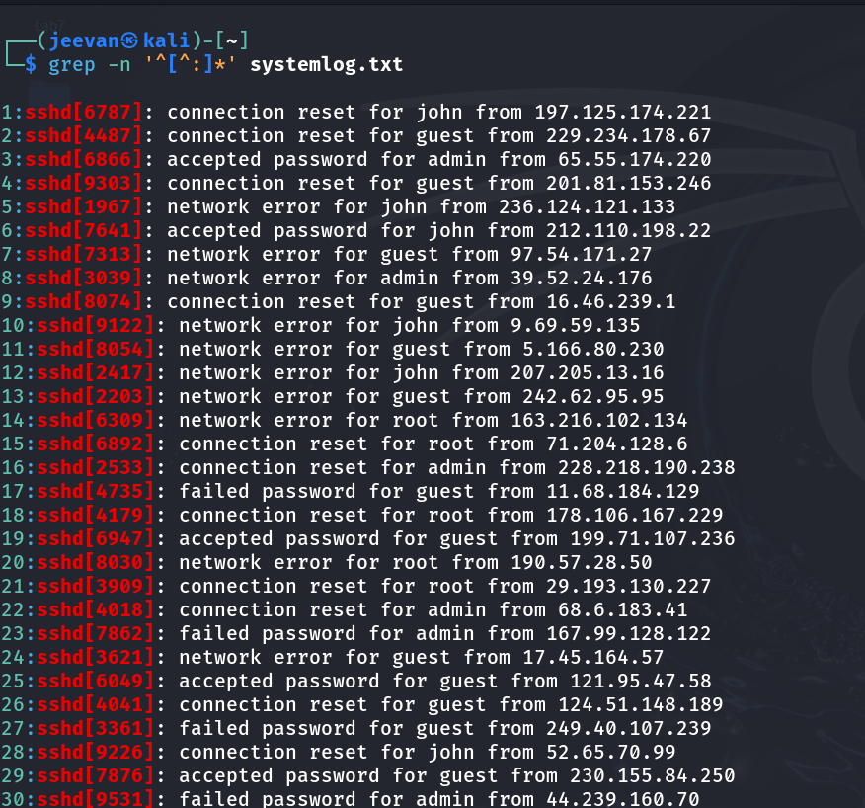

**Search for a specific user** (e.g., "john") and ignore case sensitivity:

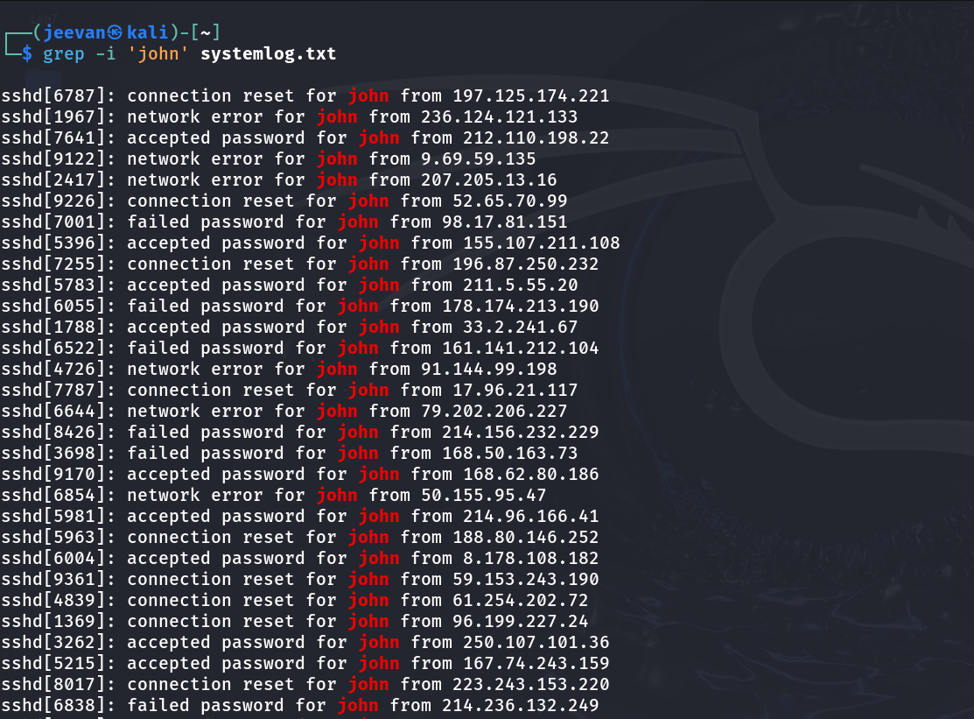

**Extract user information using a pattern from a file** (e.g., users in the admin group):

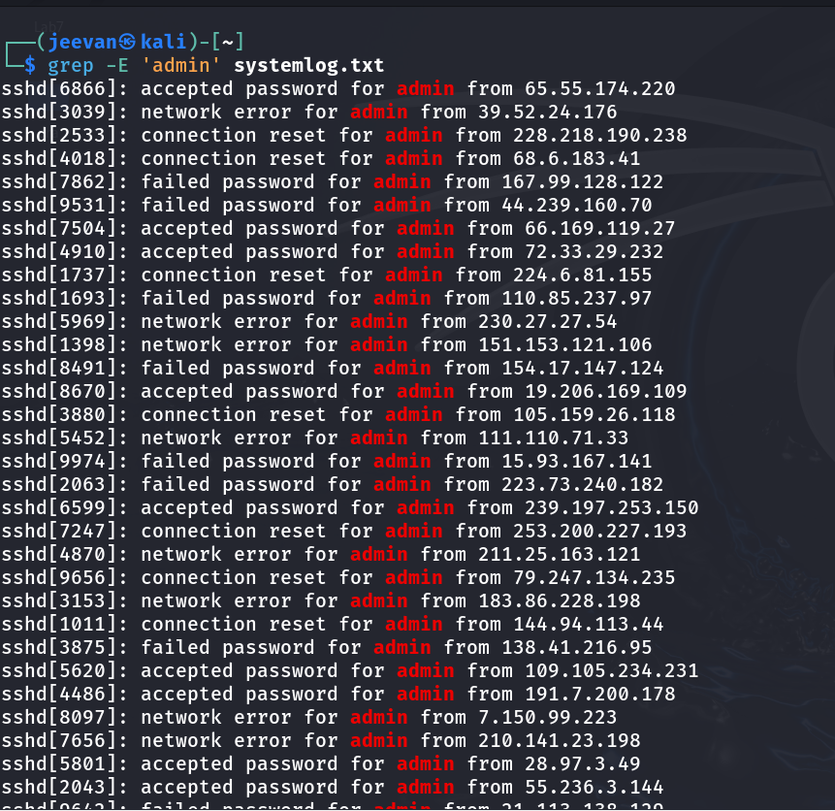

**Show a few lines before matching**:

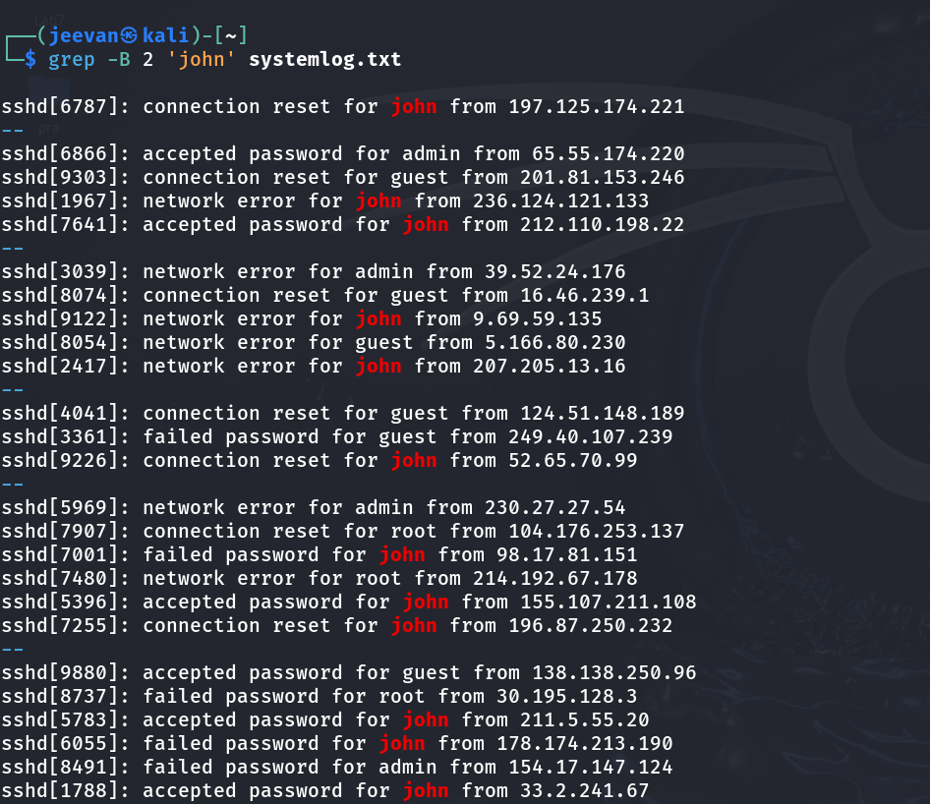

**Search for specific IP address (e.g., 192.168.1.1) in network logs**:

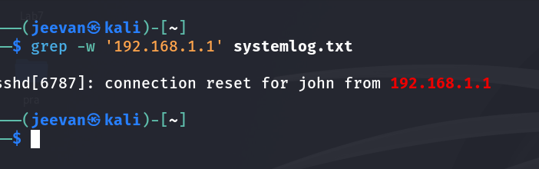

**Show a few lines after matching**:

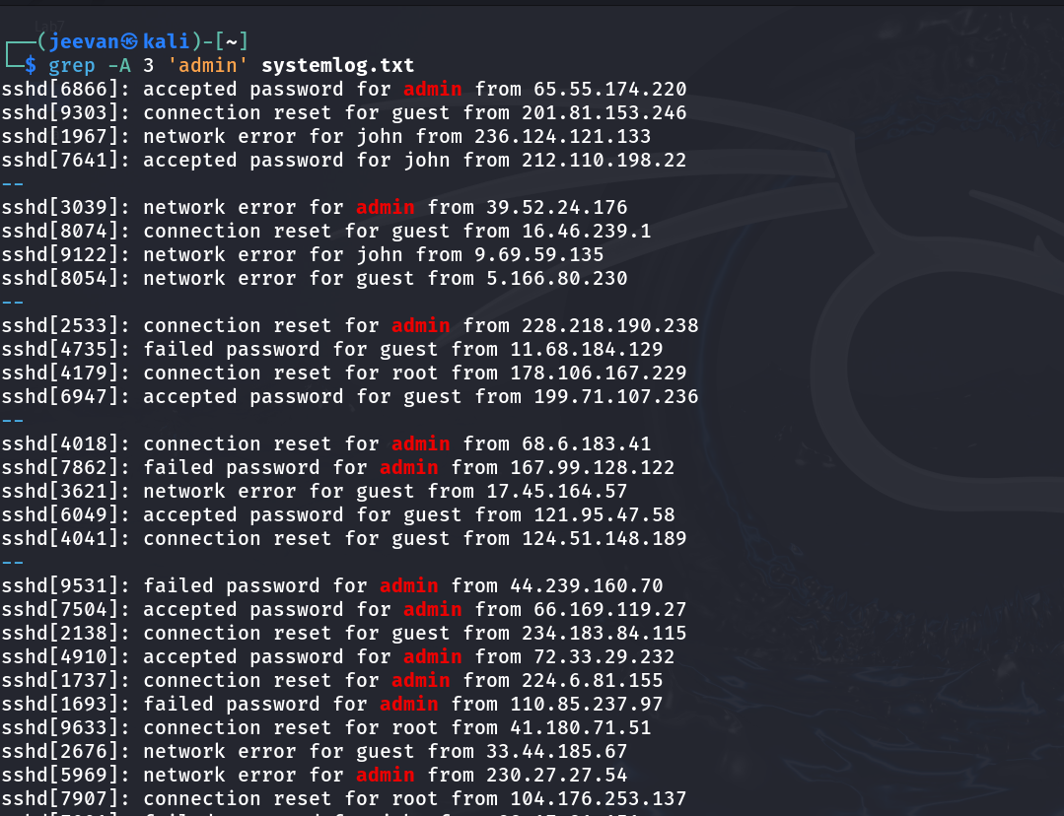

**Search for network activity**:

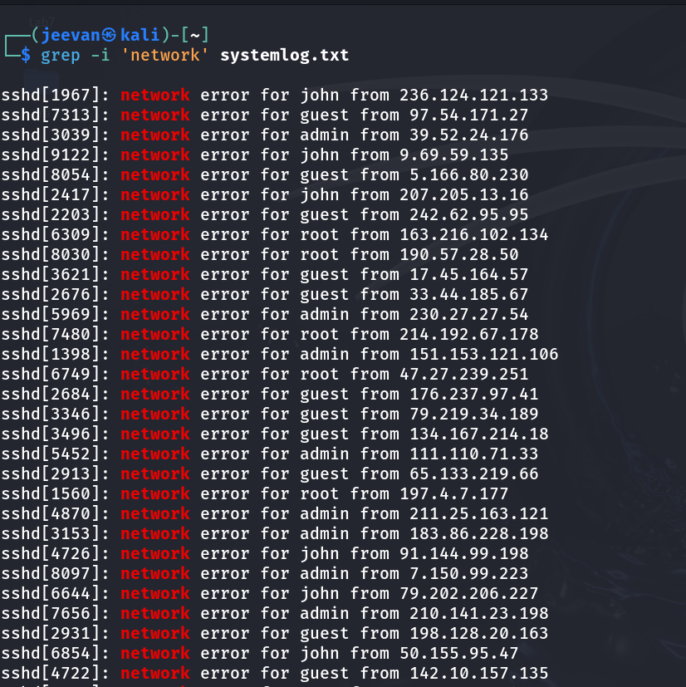

**Search for specific IP address (e.g., 192.168.1.1) in network logs**:



**Count occurrences of a specific network-related error (e.g., "connection reset")**:



**Display all lines that contain an IP address** (pattern matching):

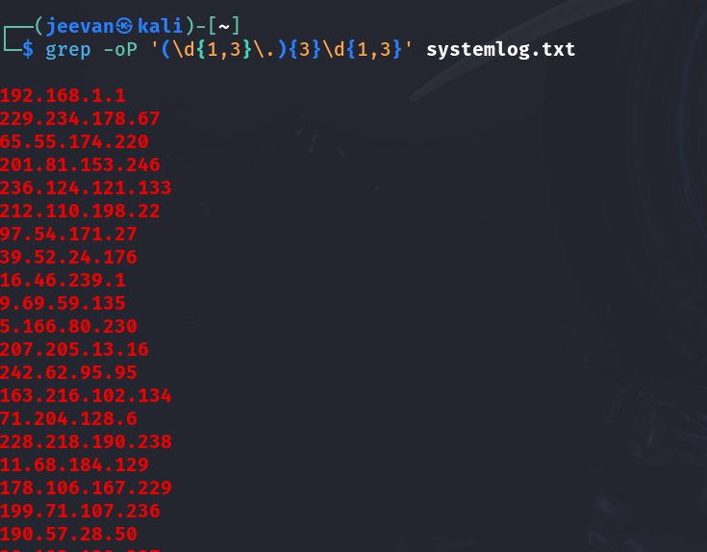

**Show context around the network error**:

